## Annexure A

## SUMMARY TABLES:

According to the budgeted monthly operational and capital expenditure submitted by all municipalities as supporting tables to the adjusted budgets, municipalities recorded an over performance of 0.8 per cent or R1.2 billion on billed revenue, an over performance of 5.3 per cent or R7.7 billion on operational expenditure and an under performance of 16.3 per cent or R643.8 million on capital expenditure.

## Consolidated statement of financial performance



## Consolidated statement of financial position



## Aggregated revenue and expenditure for municipalities





## Salaries and wages



## Aggregate revenue and expenditure trends for metros







## Aggregated revenue and expenditure for secondary cities







## Operating revenue and expenditure per function for metros









## Operating revenue and expenditure per function for secondary cities









## Aggregated municipal debtors age analysis



## Debtors’ age analysis for the metros





## Debtors’ age analysis for secondary cities





## Aggregated municipal creditors age analysis





## Borrowing instruments

##### 

 

**

 

## Investment instruments

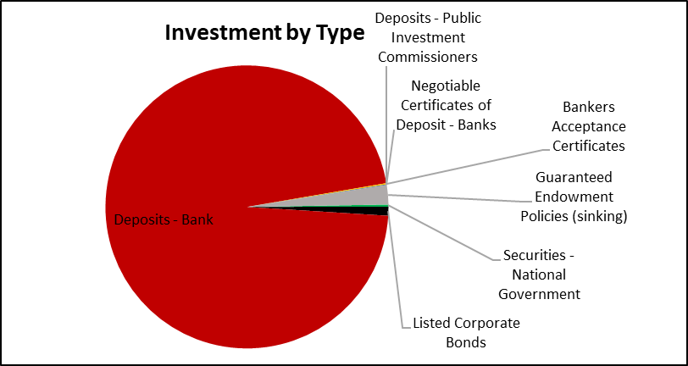



## Non-financial information in terms of the MFMA Circular 88 (Attached as Annexure B)

## Cash balances (Attached as Annexure C)

## Conditional Grants

